

MRP Update Process

Trent Limited

Process Document

This user’s guide includes the Process Document defined for the application.

Prepared By: Leena Patil

Version Number: 1.0.0

BAR CODE INDIA, 145 Udyog Vihar Phase I, Gurugram, Haryana-122016, PH: 0124 4337555

BAR CODE INDIA, 691 UDYOG VIHAR PHASE V, GURUGRAM, HARYANA - 122016, Ph.: 0124 4337555

Notice:

This document contains information, which is the proprietary property of Bar Code India. This document is received in confidence and its contents cannot be disclosed or copied without the prior written consent of Bar Code India.

Nothing in this document constitutes a guaranty, warranty, or license, express or implied. Bar Code India disclaims all liability for all such guaranties, warranties, and licenses, including but not limited to: Fitness for a particular purpose; merchantability; not infringement of intellectual property or other rights of any third party or of Bar Code India; indemnity; and all others. The reader is advised that third parties can have intellectual property rights that can be relevant to this document and the technologies discussed herein and are advised to seek the advice of competent legal counsel, without obligation of Bar Code India.

Bar Code India retains the right to make changes to this document as per discussion with the Customer.

COPYRIGHT

Copyright © ***BCI*** 2023. All rights reserved.

TRADEMARKS

*Other product and corporate names may be trademarks of other companies and are used only for explanation and to the owners' benefit, without intent to infringe.

Revision History

|  |  |  |  |  |
| --- | --- | --- | --- | --- |
| Revision Number | Date | Prepared By | Reviewed By | Comment |
| 1.0 | 10-Jan-2023 | Leena Patil | Suraj Raut | Process Document |

Table of Contents

1 Protocol Approval 1

2 Purpose 2

3 Scope 2

4 Process Execution 3

5 Summary and Conclusion 6

# Protocol Approval

|  |  |  |
| --- | --- | --- |
| **Prepared By** | | |
| **Name** | **Designation** | **Signature & Date** |
| Leena Patil | Technical Writer |  |
| **Checked** **By** | | |
| **Name** | **Designation** | **Signature & Date** |
| Suraj Raut | Software Engineer |  |

|  |  |  |  |
| --- | --- | --- | --- |
| **Approved By** | | | |
| **Department** | **Name** | **Designation** | **Signature & Date** |
| Software | Ritu Kapoor | Head of Engineering |  |

# Purpose

The purpose of process document to understand the MRP update flow.

# Scope

The scope of this document is to perform the process for MRP Update.

# Process Execution

1. Receive the data from SAP in **tblSAPMovementDetailMaster** table according to movement type.

*\*The data will be received to* ***tblSAPMovementDetailMaster*** *table.*

1. 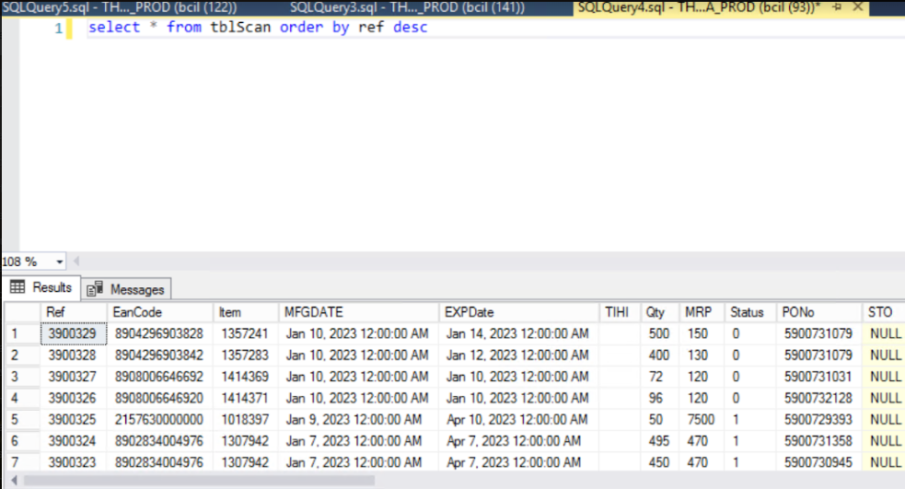Pick latest MRP from **tblScan** table store-wise:
2. Update the MRP in **tblBatch** table:

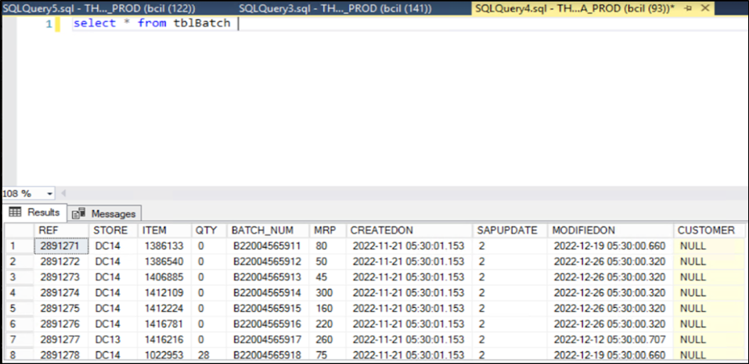

1. 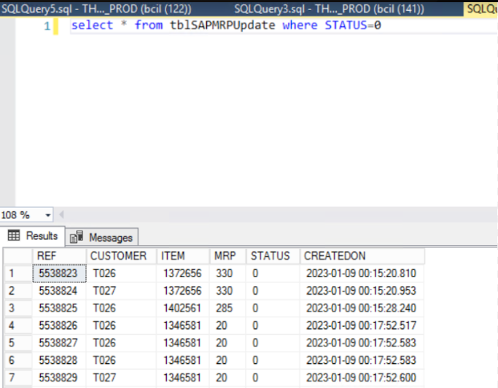Store wise MRP will be created in **tableSAPMRPUpdate** table.
2. Then the store wise data will be posted to SAP.
3. Batch program in the SQL Server Agent will be scheduled to update the MRP.

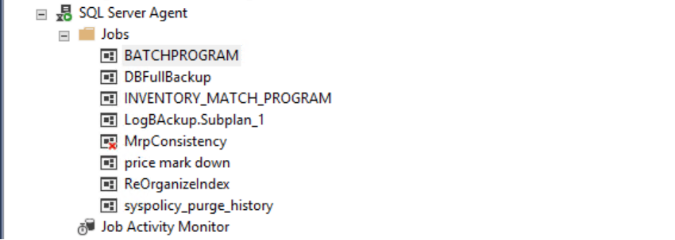

1. Data updated time is set in the Batch Program by use of Scheduler.

*\*The MRP update time is set at 23:00 pm every night.*

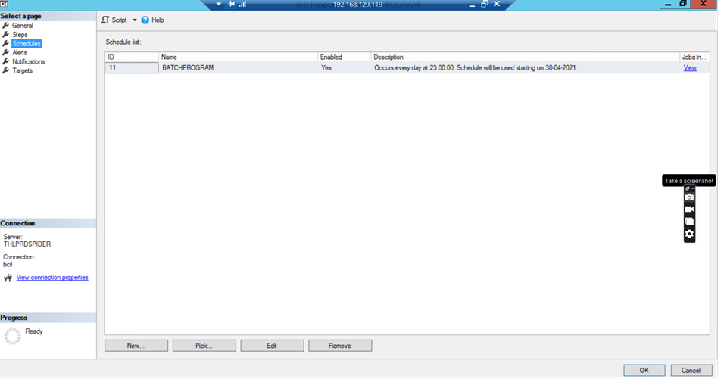

1. The Task Scheduler will be used to automatically trigger the transfer of data to SAP once the MRP update process has been completed.

*\*This transfer will occur daily at 22:00 pm.*

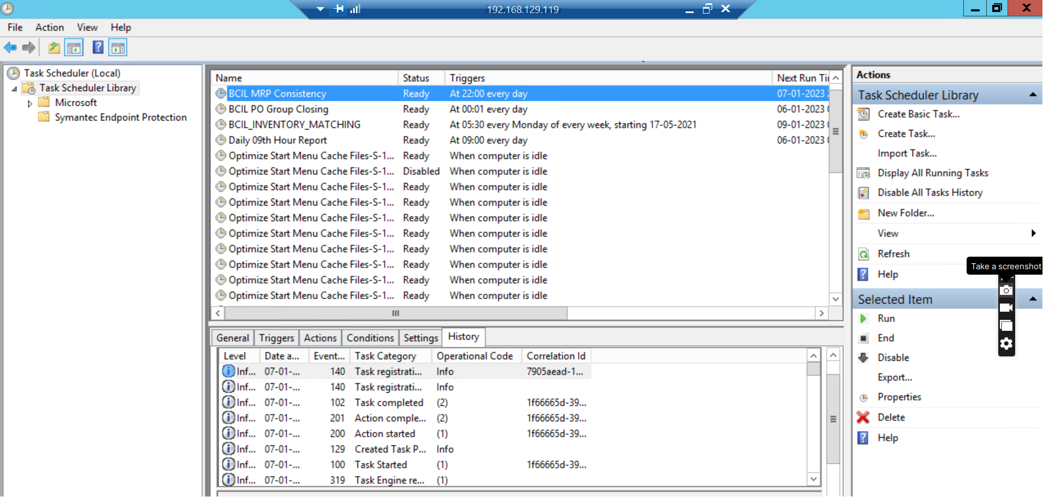

1. The data gets posted to SAP after the completion of the above process.

# Summary and Conclusion

This document outlines the process for transferring MRP data to SAP, including uploading the MRP data and synchronizing it with SAP using the steps outlined in the document.

The process steps for transferring data are outlined in the document, providing the user with an understanding of how to upload and store data in SAP.

.

Process Document

MRP Update, Trent Limited

Confidential & Copyright©2023